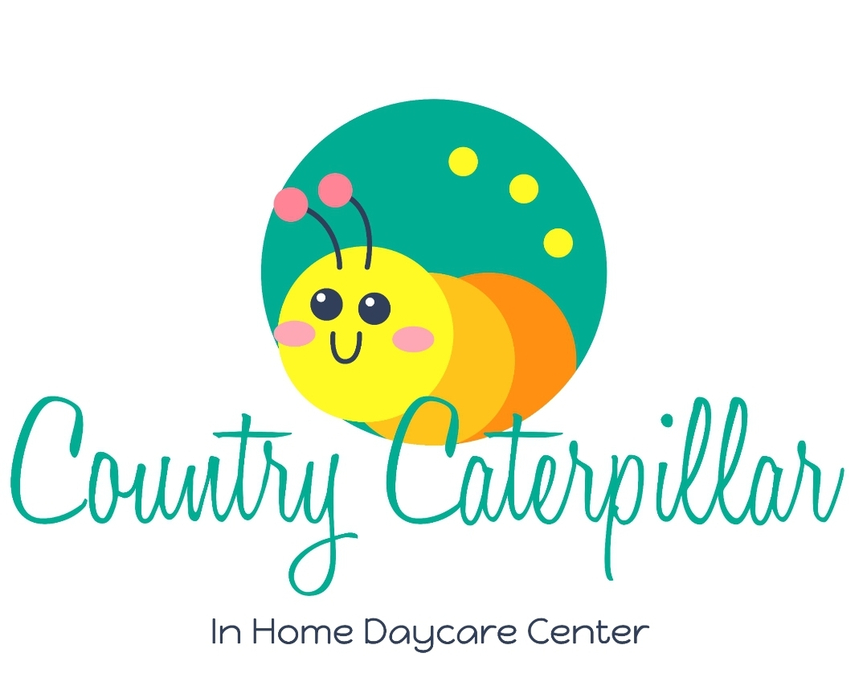
Dear Prospective Parents,

Thank you so much for considering Country Caterpillar Daycare for your child! I am contacting you because you showed interest in having your child attend and I would like to provide you with a little more information about my program. After reading this letter, if you would like to apply to have your child attend, please fill out the form on the next page and return it to me at your earliest convenience. This form will give me some insight into your family and your specific needs. If I can accommodate your needs, I will contact you to schedule an in person interview to see if we would be a good fit.

Location: 28127 68th Ave NW Stanwood,WA 98292

Hours: Monday To Friday 7am to 5pm

Rate: See attached tuition sheet

2 Meals and 2 Snacks provided daily in the cost

Country Caterpillar Daycare is a play based childcare program. Free play encourages each child to use their creativity, develop their imagination, interact with others, build their confidence, share and resolve conflicts, practice decision-making skills, problem-solving skills, and enhance their learning readiness. The children spend most of their day in free play outside of meals, snacks, and naptime.

Thank you again for your interest,
Eva Pemberton
Country Caterpillar Daycare - Owner
Parents, please fill out this form before consideration for in person tour:
Name and Gender of Child:
Names of Parents/Guardians:
Birth Date and Current Age of Child:
Date you would need childcare to begin:
Schedule of care that you would need (days and pick up & drop off times):
Describe your child’s typical daily routine:
Does your child nap? If so, describe your child’s typical naptime routine.
Is your child potty trained or currently potty training? (skip if under 2)
Does your child have any special needs (medical conditions, food or medical allergies, developmental, etc.)?
Do you have options for alternative care/ back up care if I should need to close for sickness or emergencies?

Has your child attended daycare before? How was that experience for them?
Is there anything else I should be aware of to properly care for your child?

What do you hope your child gains by attending my program?

How did you hear about Country Caterpillar Daycare?

Any immediate questions for me?

